Component 2

ADVANCED WEB ENGINEERING

Leeds Beckett University | The British College

Advanced Web Engineering



**Student Name: Sandesh Paudel**

**Level: 6**

**Module: AWE**

**Tutor: Pratik Shrestha**

Table of Contents

PROJECT INTRODUCTION 2

TECH-STACKS USED: 2

AUTHENTICATION AND AUTHORIZATION 2

LOGIN CREDENTIALS 2

AUTHORIZATION 3

AUTHENTICATION 3

GITHUB URLs: 3

VIDEO URL 3

AREAS COVERED with proofs. 4

COMPONENT 2 REQUIREMENTS 4

Databases (Migrations) 4

.env file 5

PhpMyAdmin 6

Factory 6

Seeders 7

Models 7

Views 8

Controllers 9

Routing and HTTP Verbs 10

Authentication and Users 10

Version Control 11

UI Part 13

Homepage 13

Menu With Sorting and Searching 14

Pagination in Menu 16

VALIDATION IN LOGIN AND REGISTRATION 16

Cart Page 18

Checkout Page 19

User Order Page 19

About Us 20

Contact Us 21

Admin Dashboard 21

# PROJECT INTRODUCTION

The Silver Point Restaurant project is a project designed to optimize restaurant management operations. It boasts a range of features aimed at enhancing user experience and operational efficiency. The implementation of comprehensive Authorization and Authentication ensures that only authorized personnel can access specific functionalities. The system also incorporates advanced data management capabilities such as Searching, Sorting, and Filtering, enabling users to quickly locate and organize information. Pagination functionality further contributes to a seamless user interface, particularly in handling large datasets. With features like Add to Cart, Checkout, and Order Creation, the project facilitates a smooth customer journey, while supporting Multiple Payment Modes like PayPal and COD that enhances flexibility for patrons. The inclusion of complete CRUD operations, including image management, ensures a comprehensive approach to data manipulation. Moreover, Email Verification and Forget-Password functionalities enhance security and user account recovery. Altogether, the Silver Point Restaurant project offers a holistic solution for modern restaurant management, addressing key aspects of authentication, data handling, and customer interaction.

# TECH-STACKS USED:

* Code Editor (IDE): Visual Studio Code
* XAMPP1: MySQL Database
* CSS Framework: Bootstrap 4.1
* UI Scaffold: Breeze UI
* JS Framework: Not Used
* Database Used: MySQL with phpMyAdmin.
* JavaScript
* PayPal API for Payment Integration

# AUTHENTICATION AND AUTHORIZATION

## LOGIN CREDENTIALS

As my system have multiuser Roles:

For Admin

Email: admin@admin.com

Password: password

**For User**

Email: sandypoudel24@gmail.com

Password: password

## AUTHORIZATION

The project employs dual user authorization, distinguishing between admin and regular users. Admins access an exclusive dashboard for comprehensive system management, while regular users are directed to a user-friendly homepage. This tailored approach optimizes user experience, offering specialized features for efficient restaurant administration and customer interactions.

## AUTHENTICATION

Authentication approach enhances security by restricting access to features solely to registered users, fostering a more personalized and controlled user experience within the restaurant management system

# GITHUB URLs:

* The British College Repo (URL: <https://github.com/tbc-bsc-l6/component-2-sandesh123paudel>)
* University Repo (VLE Repo) (URL: <https://github.com/comp-bkt/component-2-sandesh123paudel>)

# VIDEO URL

* Uploaded on YouTube ( <https://youtu.be/9X-tv9r-byc> )

# AREAS COVERED with proofs.

## COMPONENT 2 REQUIREMENTS

### Databases (Migrations)

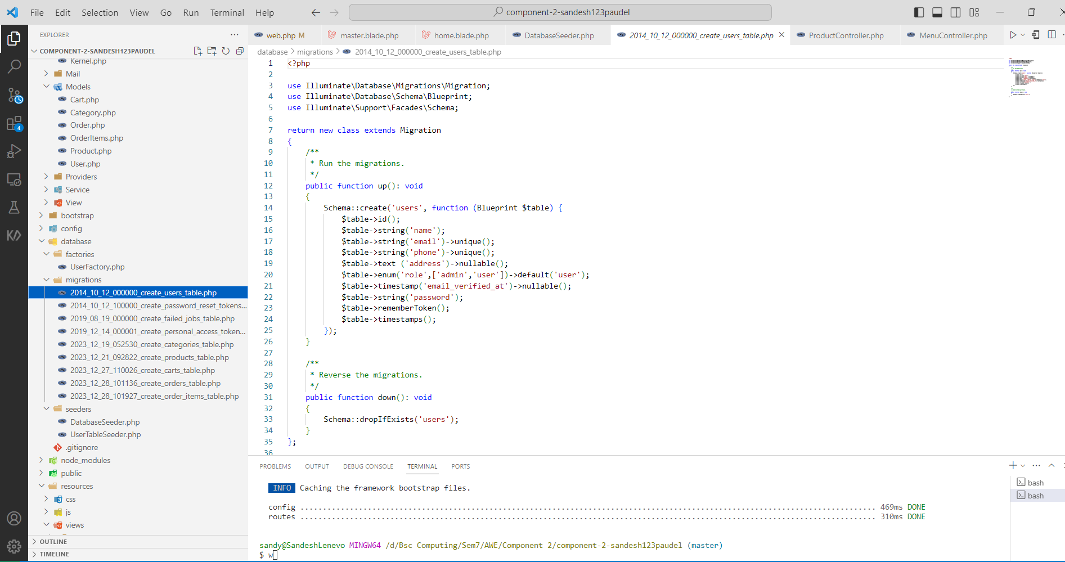

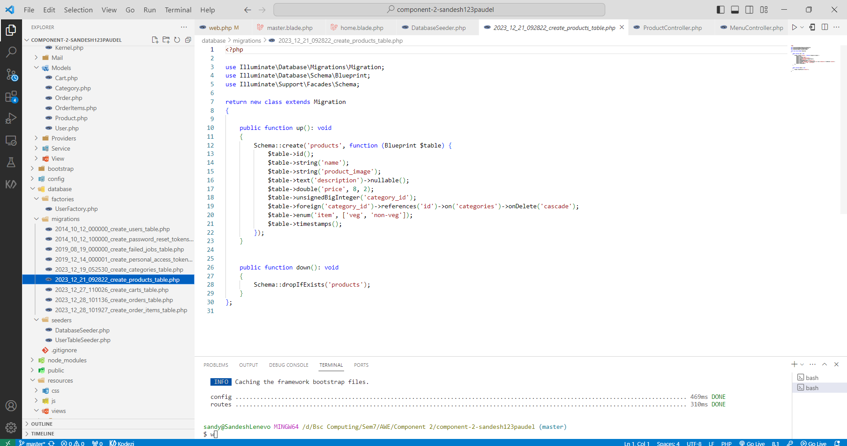

### .env file

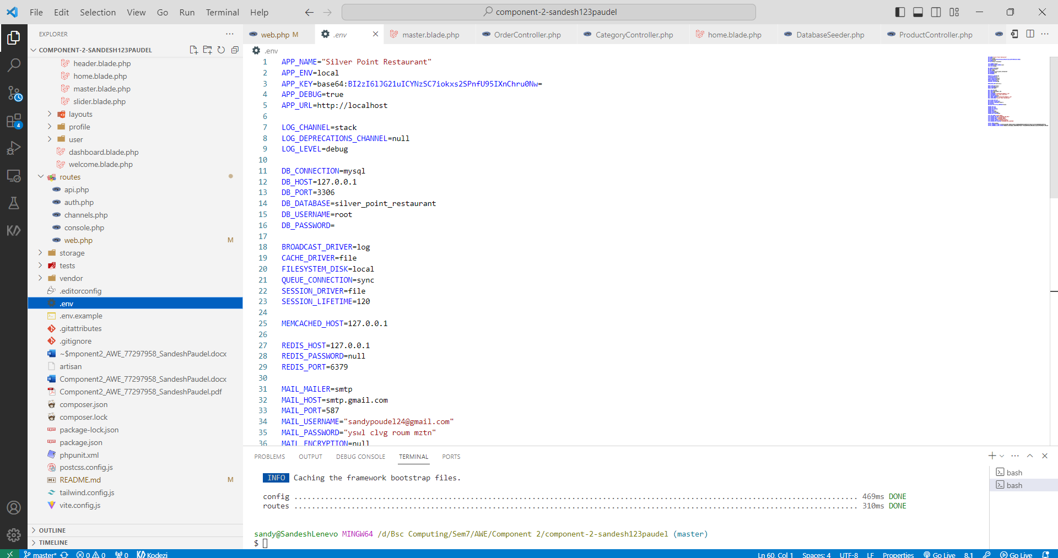

### PhpMyAdmin

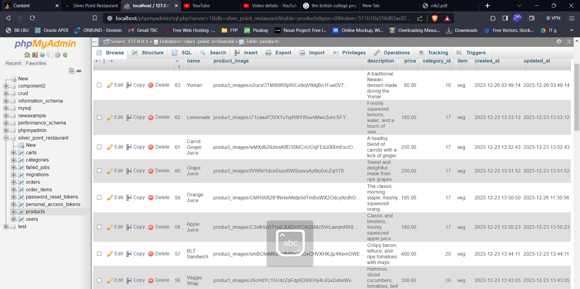

### Factory

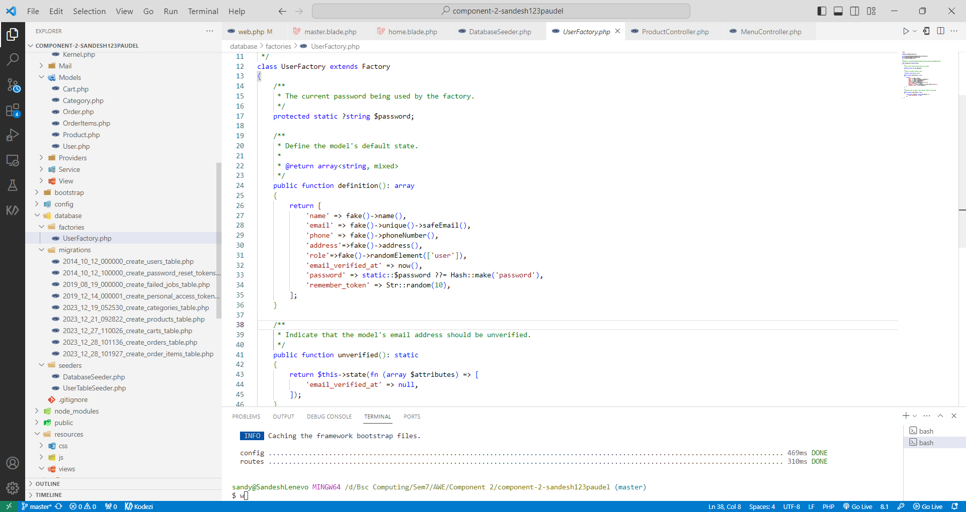

### Seeders

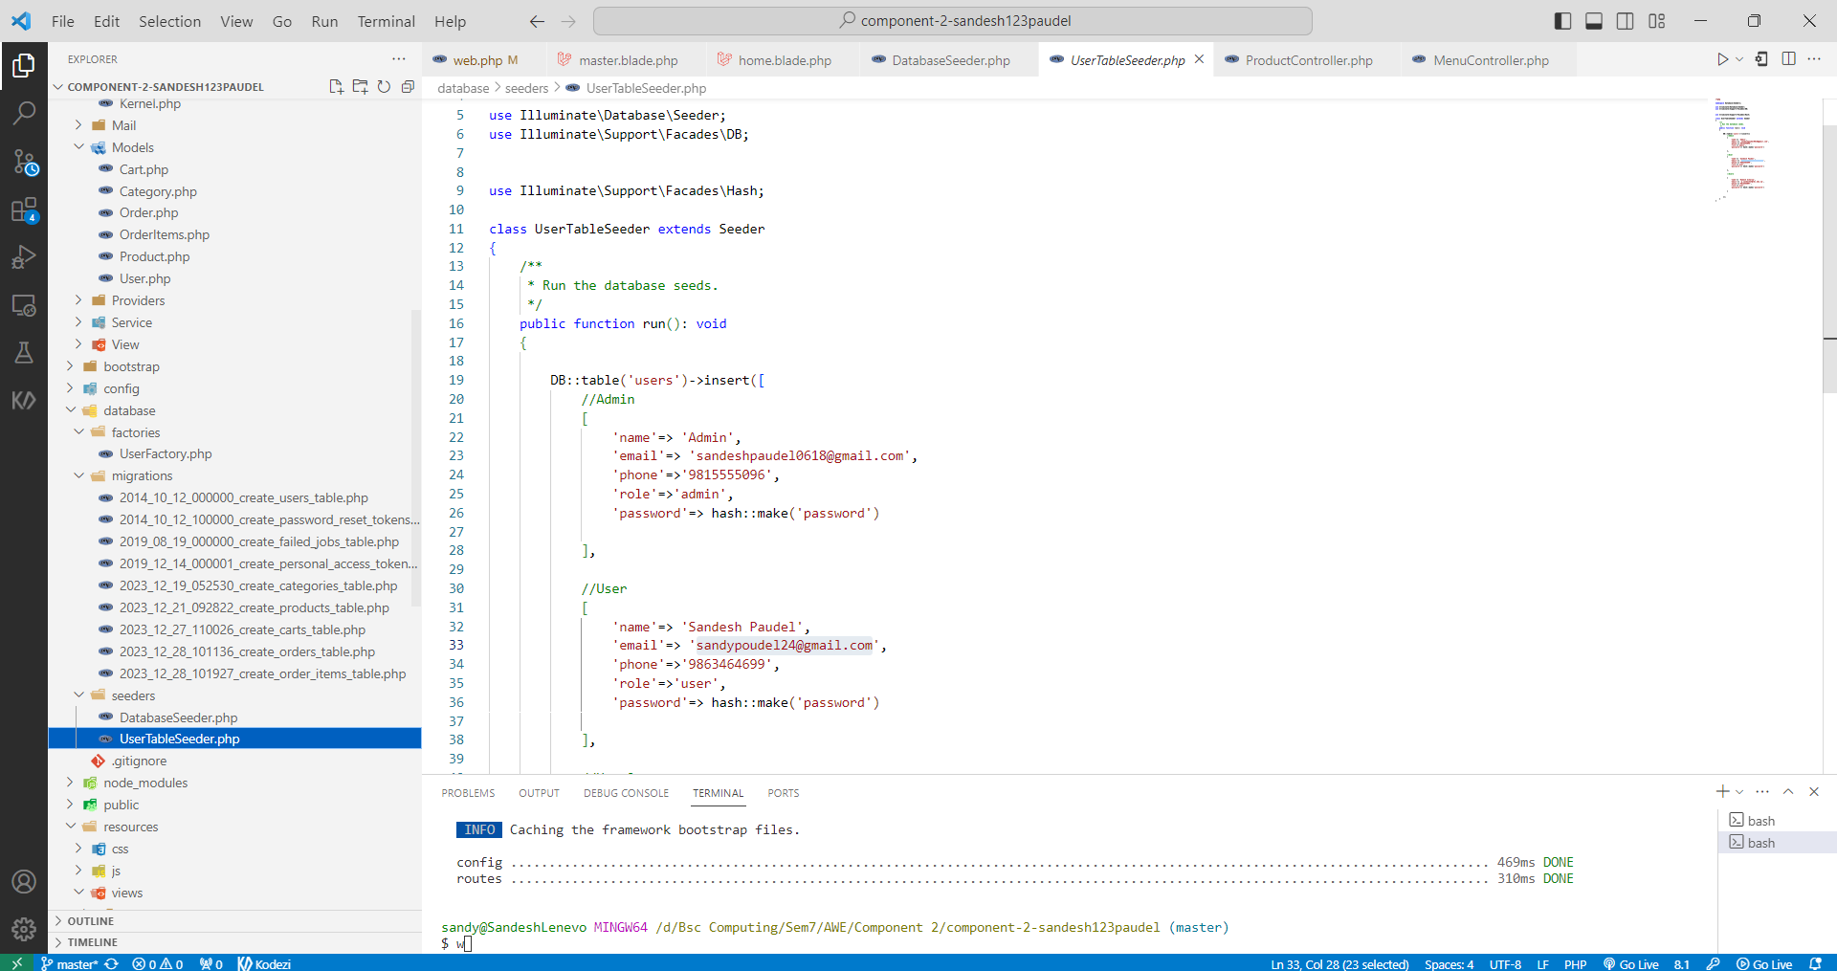

### Models

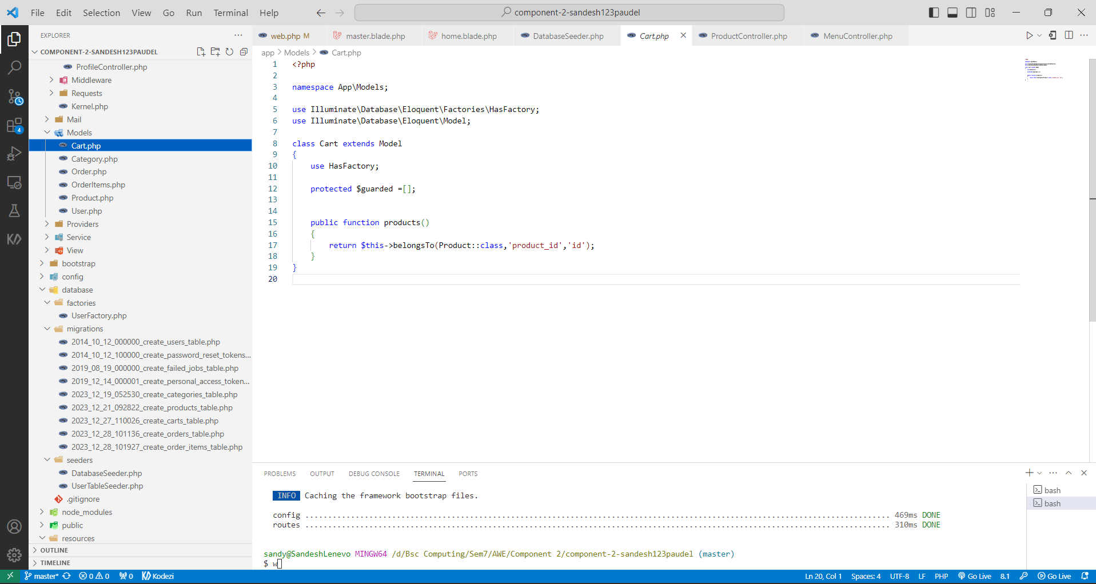

### Views

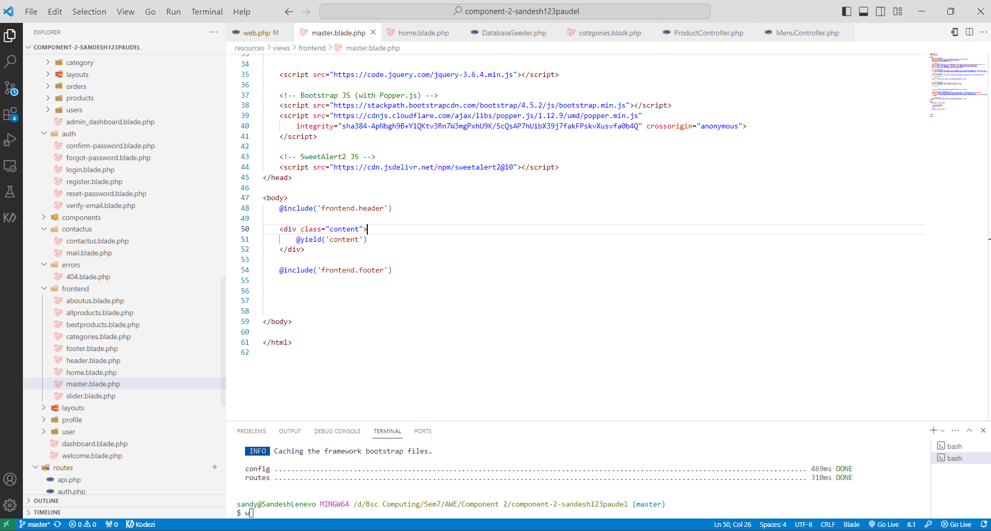

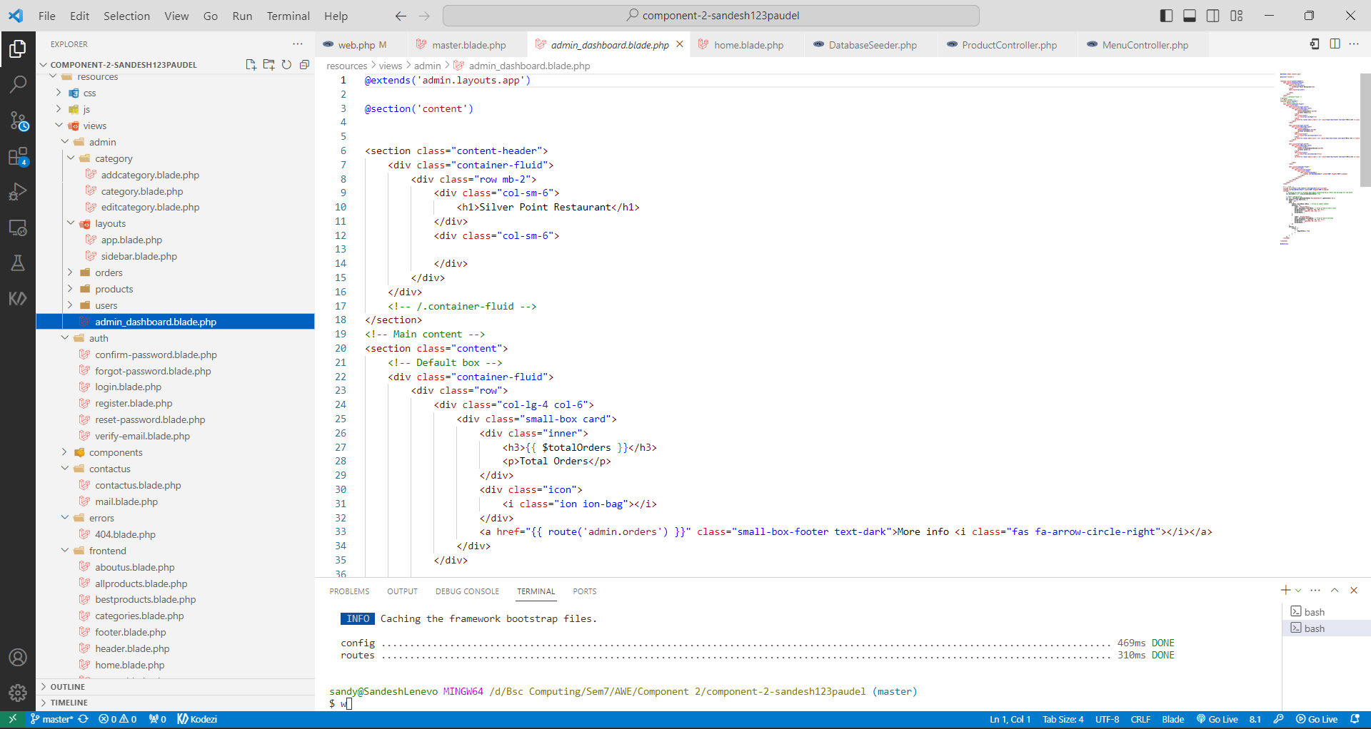

### Controllers

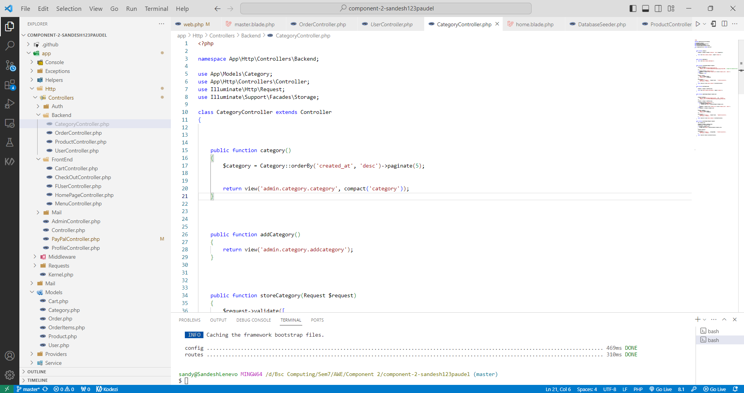

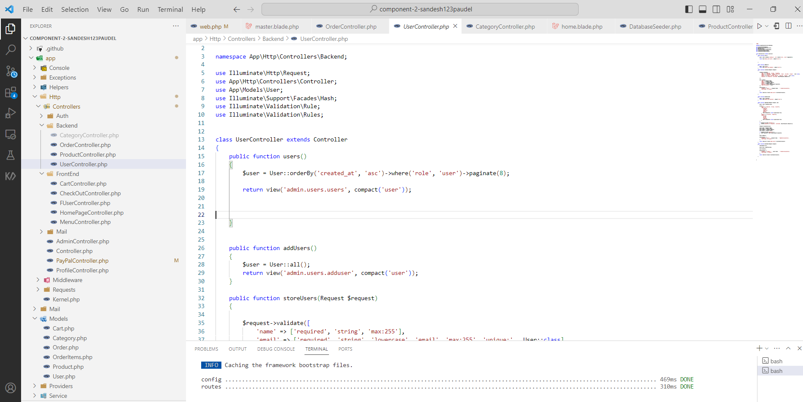

### Routing and HTTP Verbs

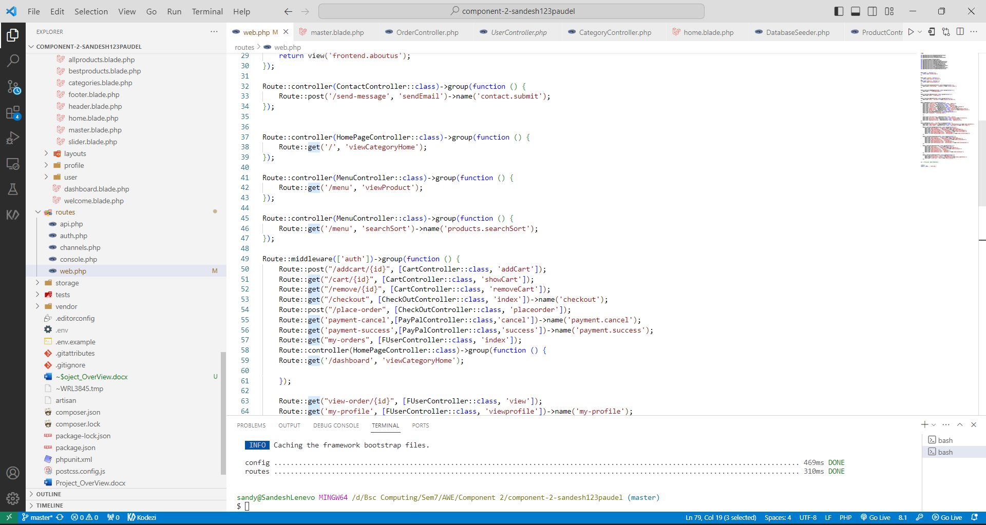

### Authentication and Users

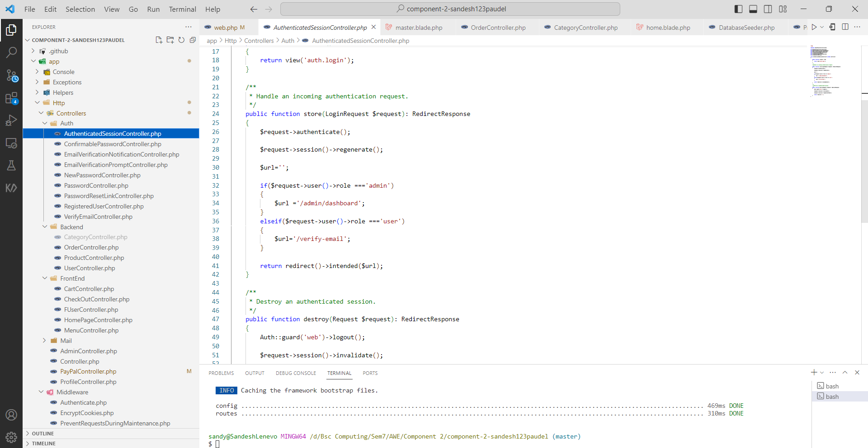

### Version Control

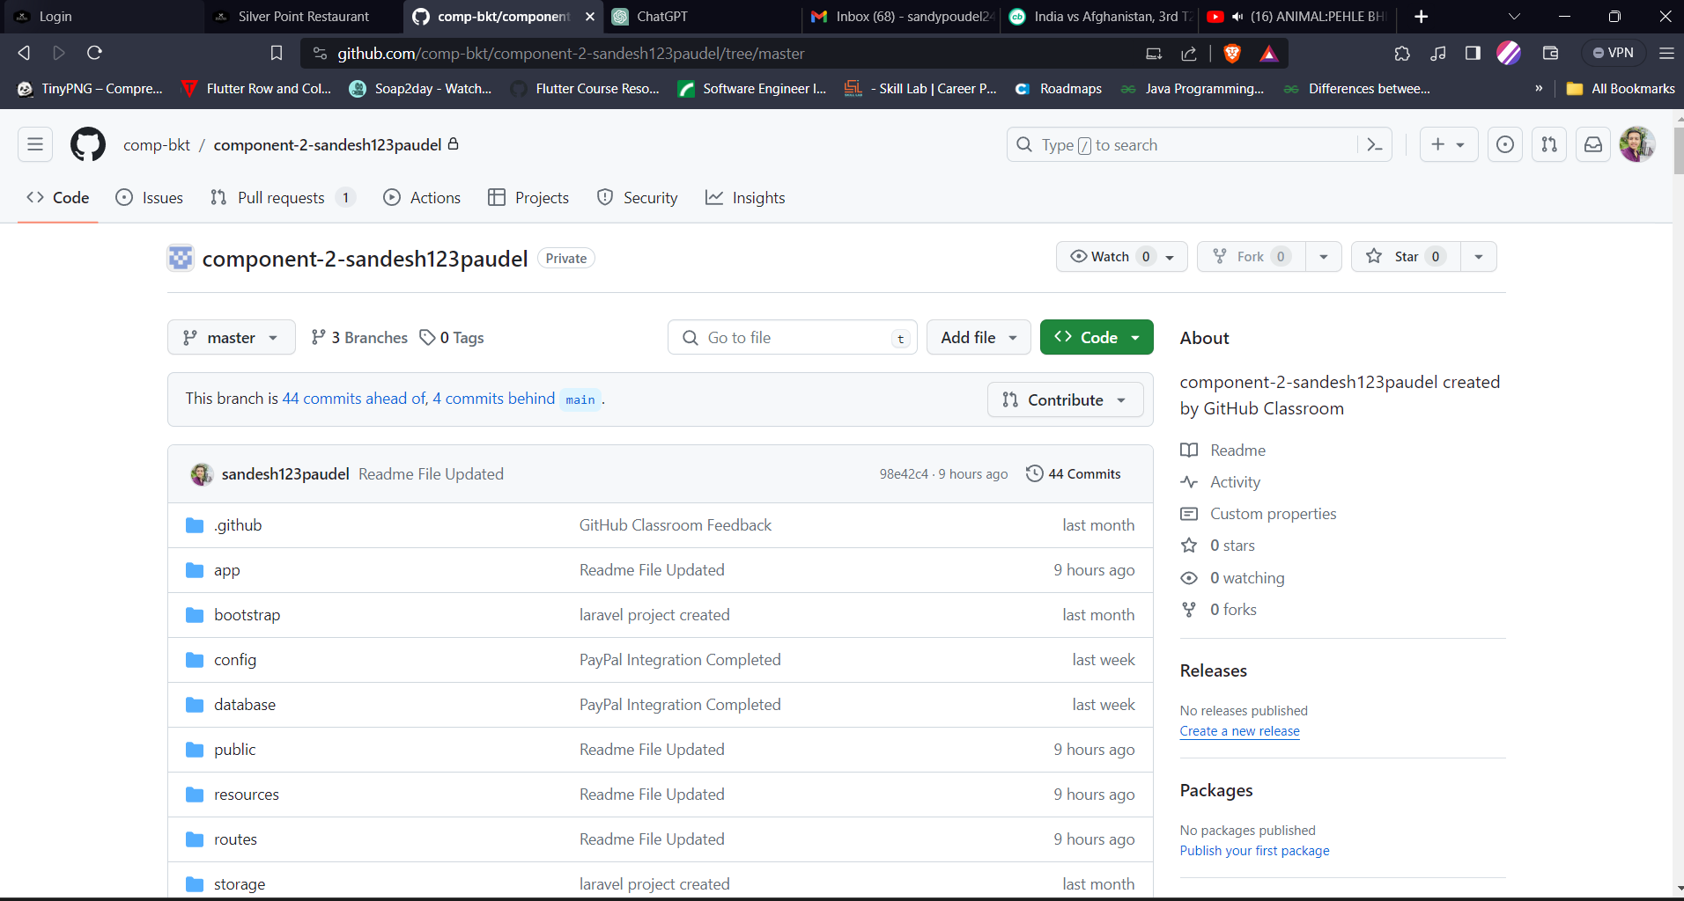

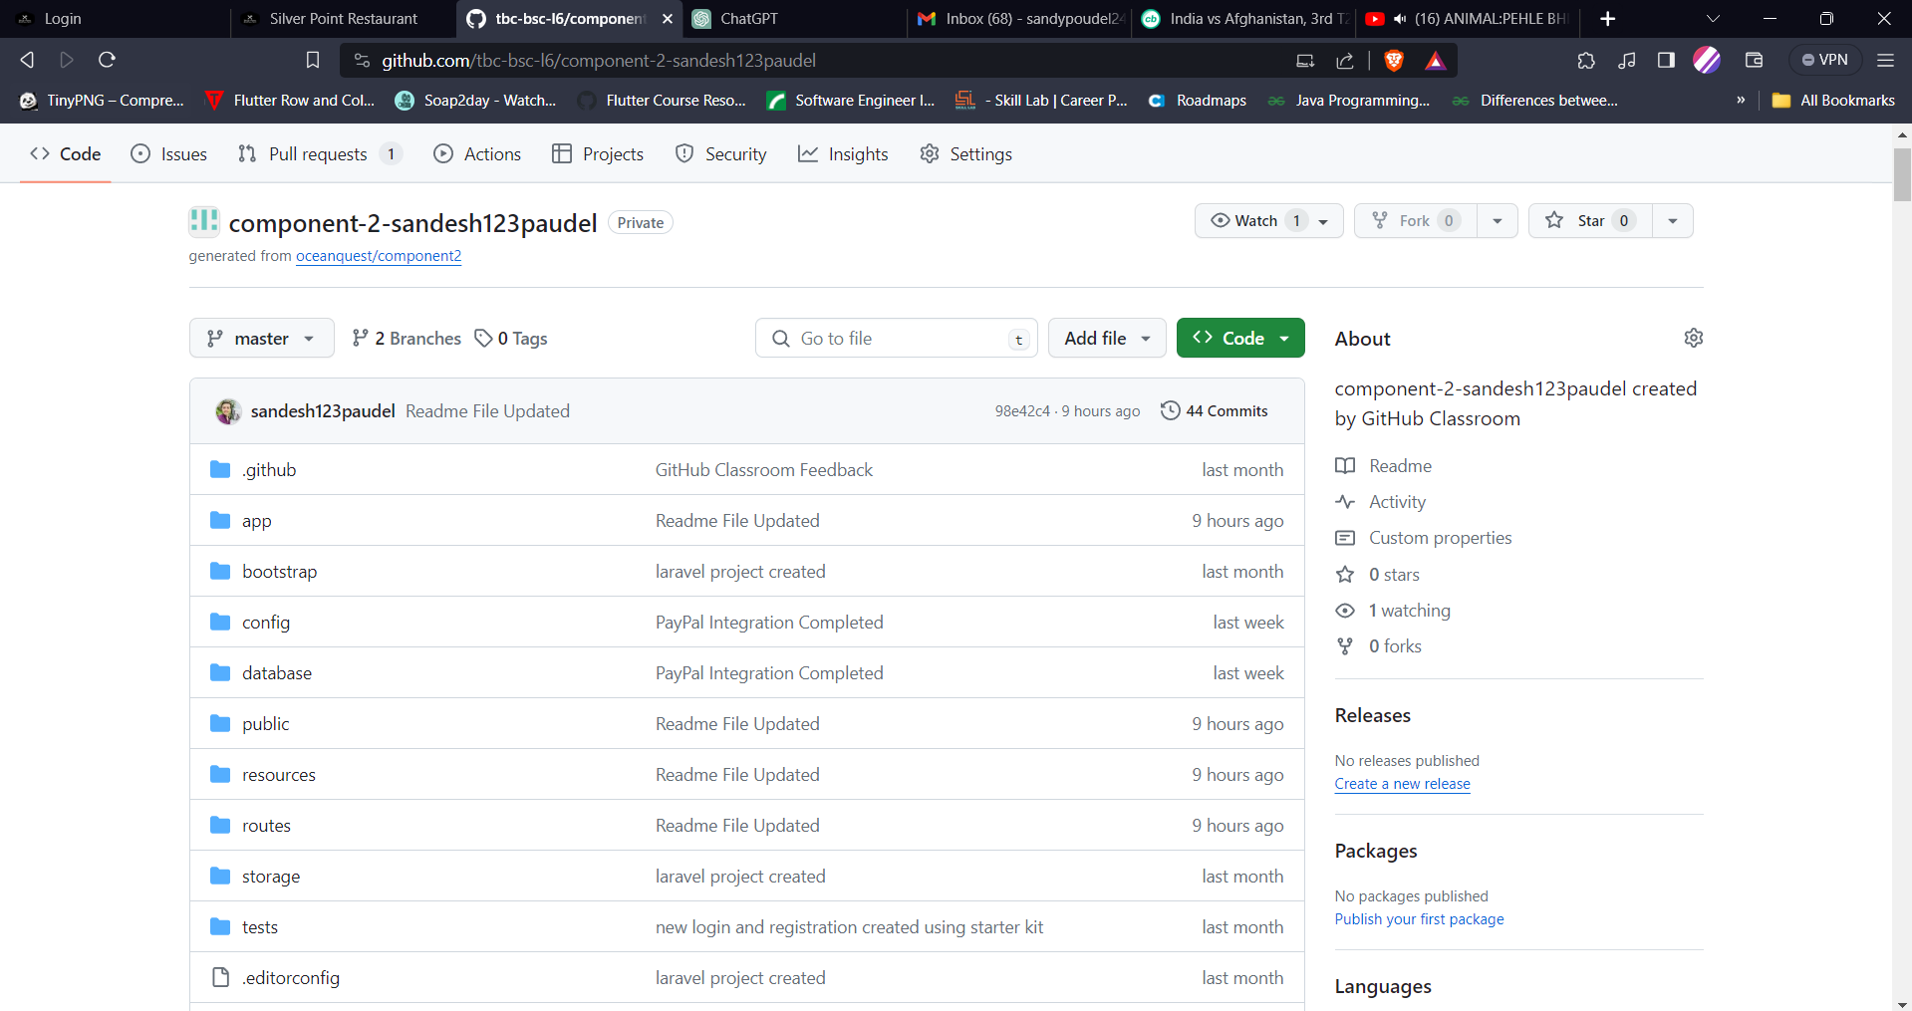

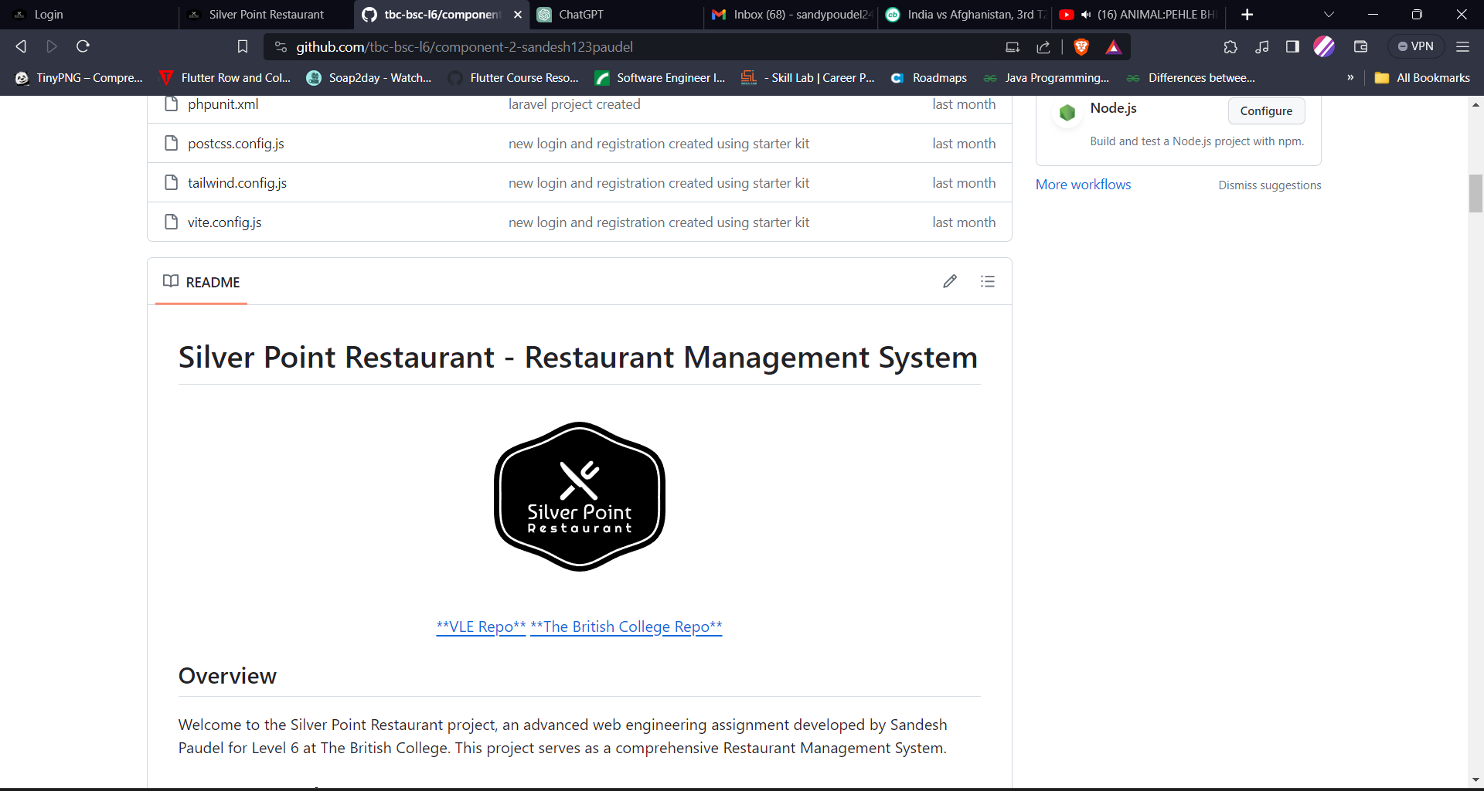

## UI Part

### Homepage

#### Without Login

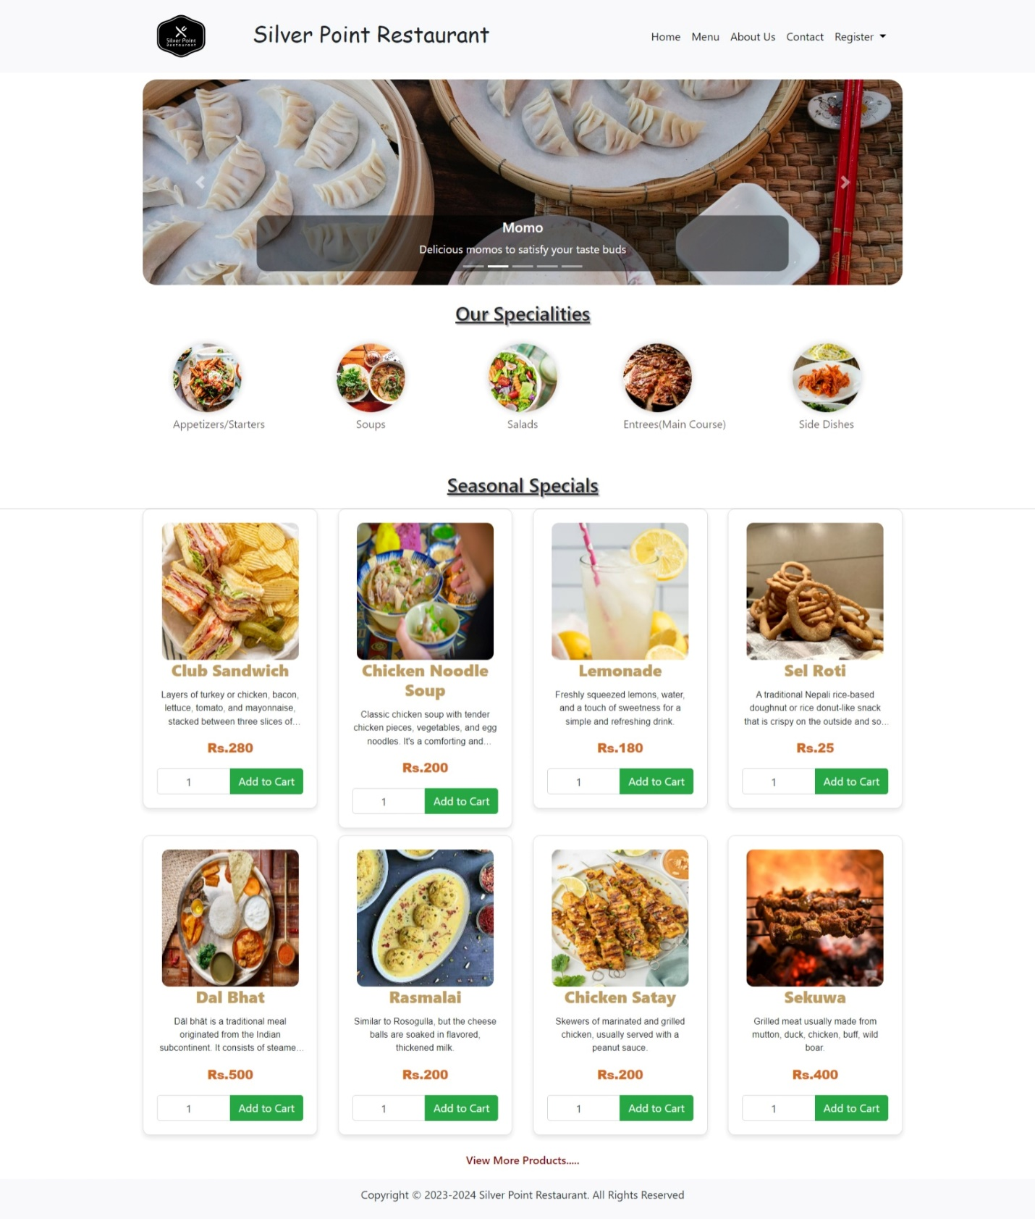

#### With User Logged In

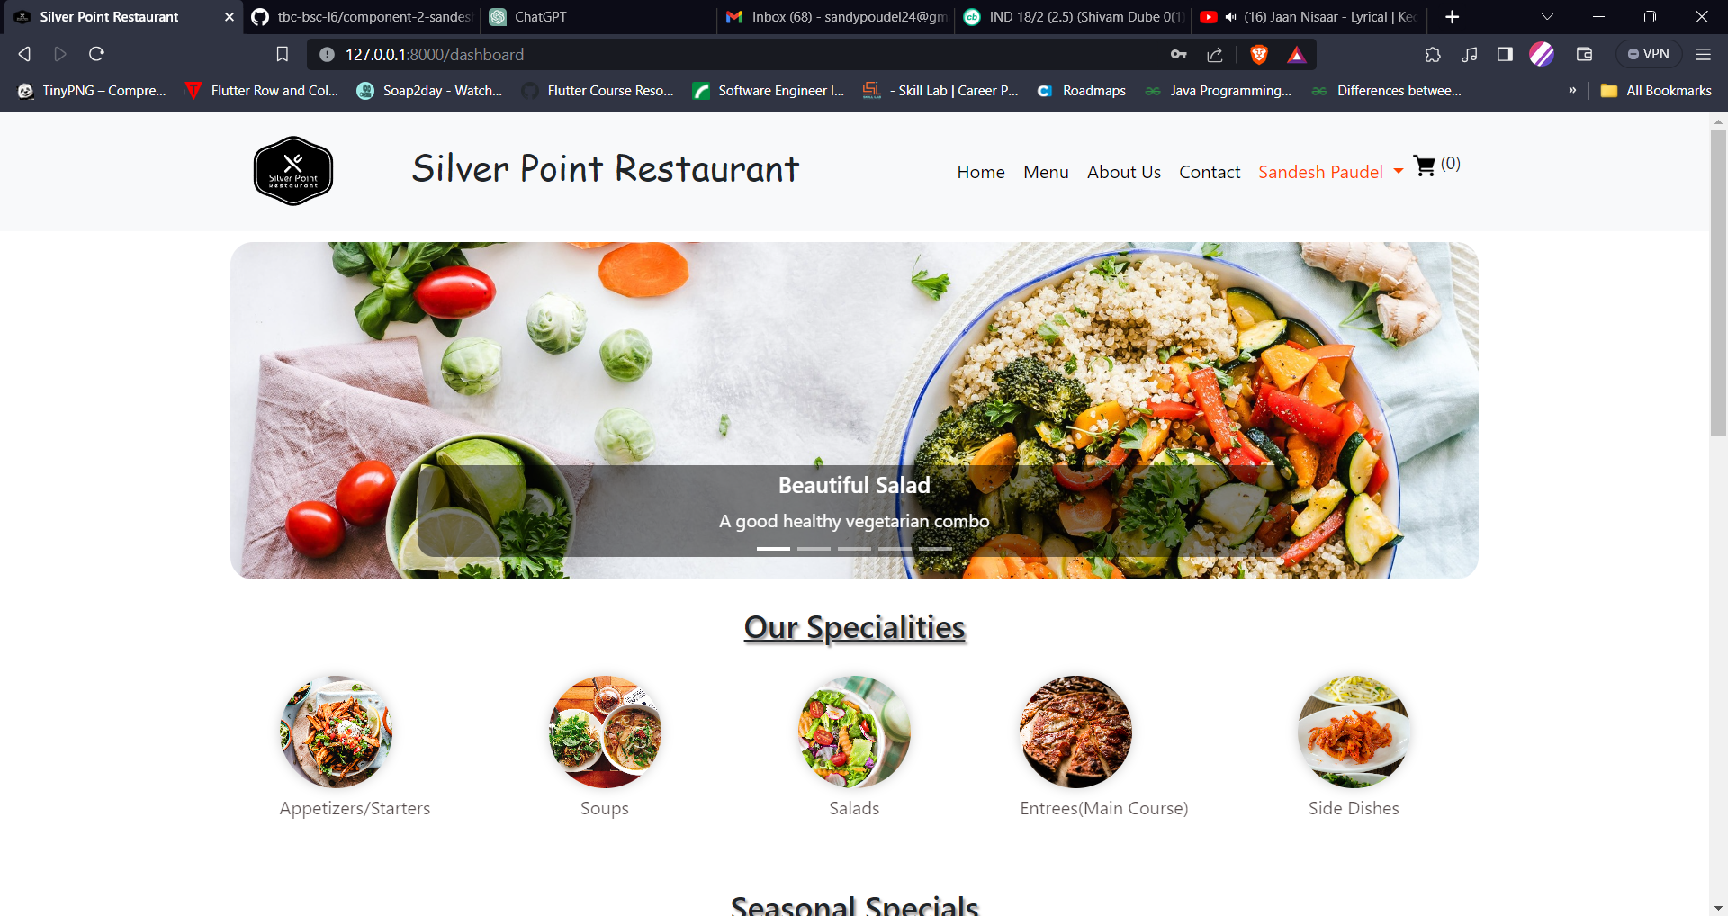

### Menu With Sorting and Searching

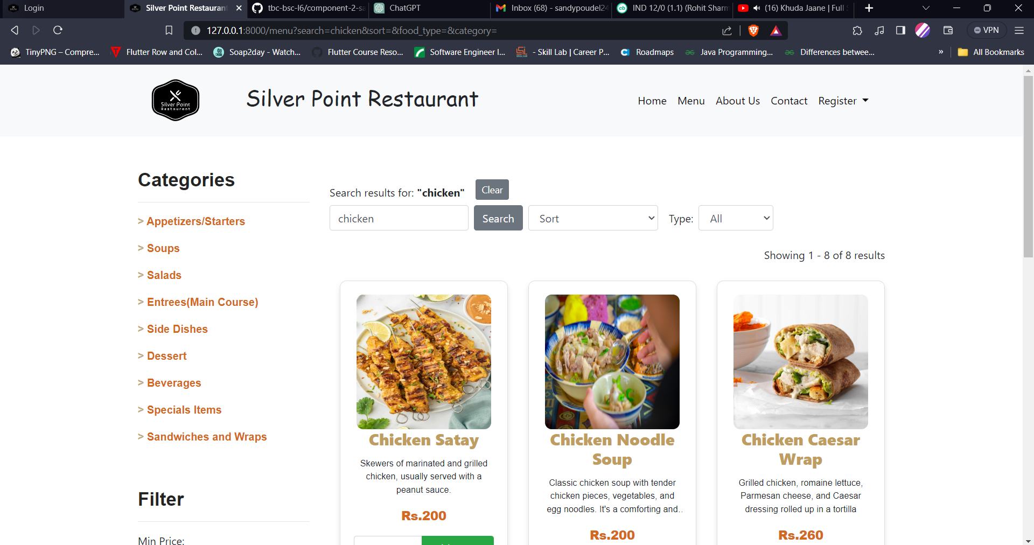

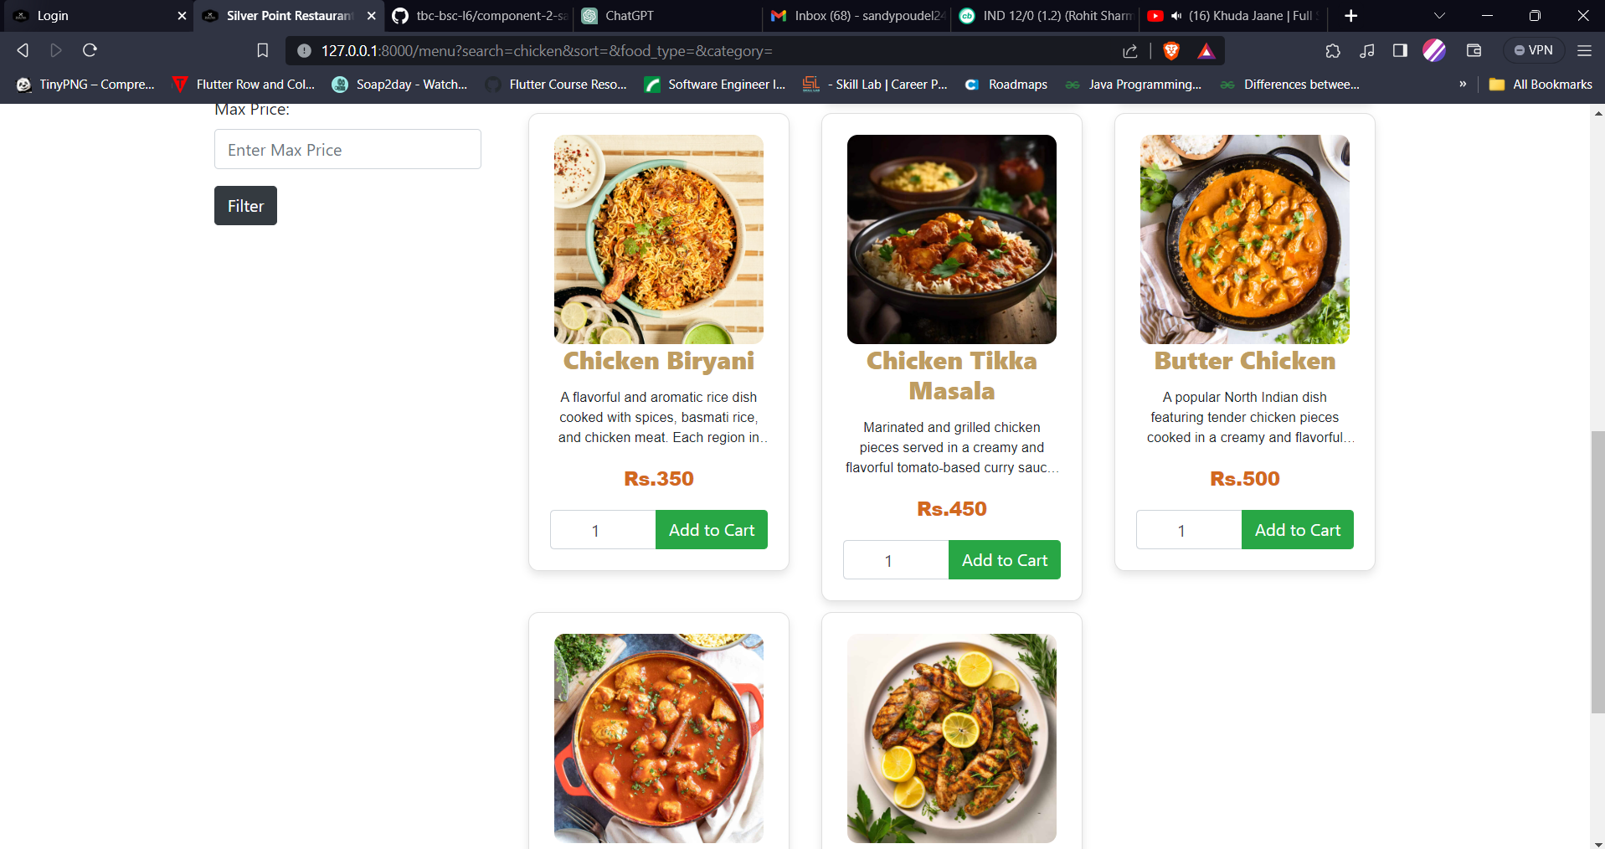

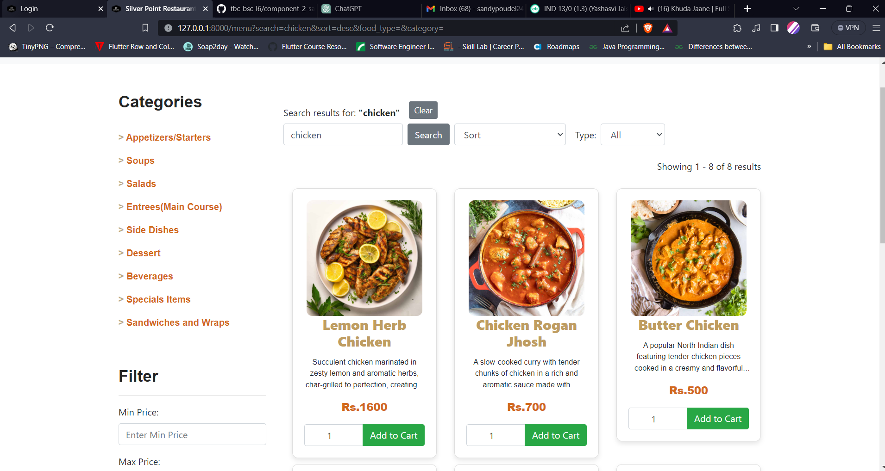

### Pagination in Menu

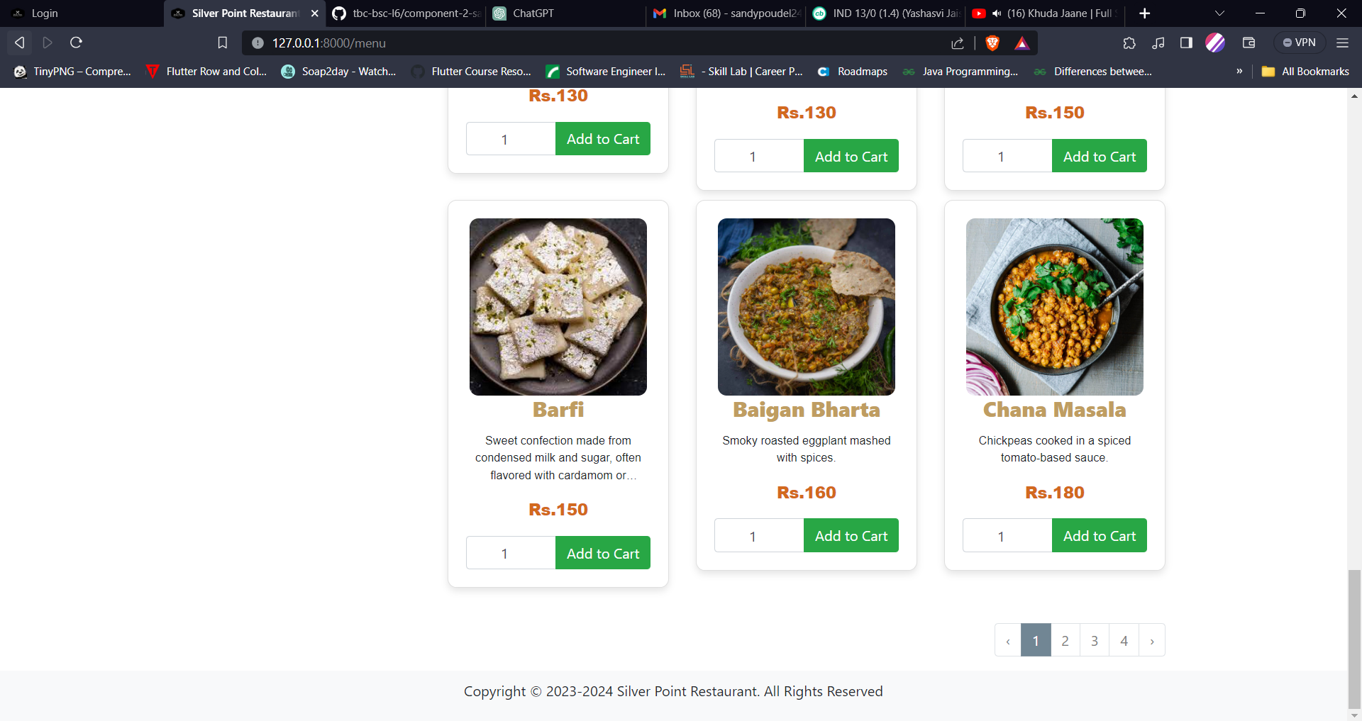

### VALIDATION IN LOGIN AND REGISTRATION

#### Login Page

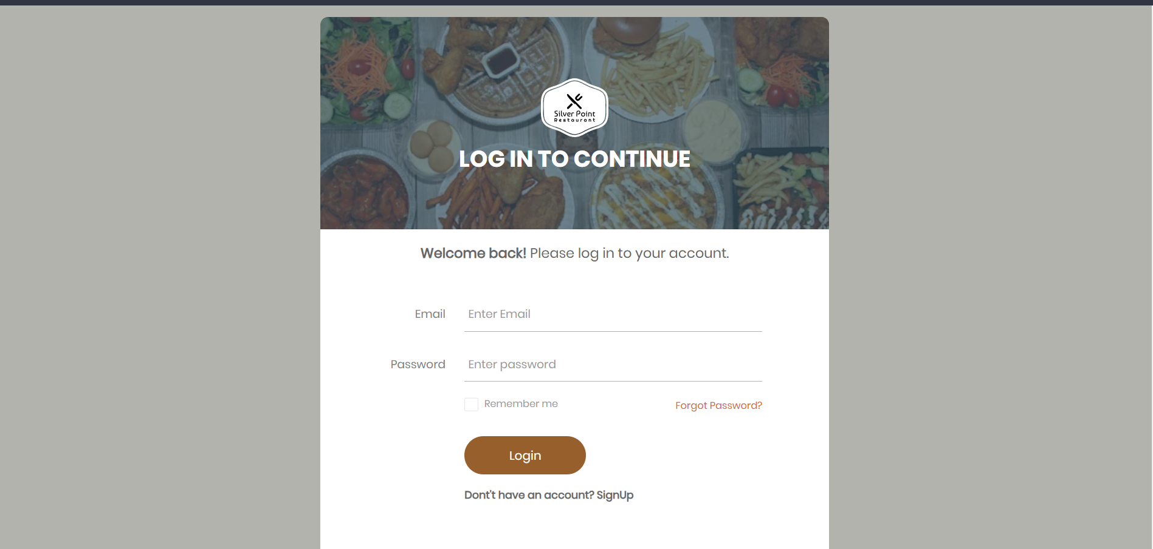

#### Invalid Login Entered

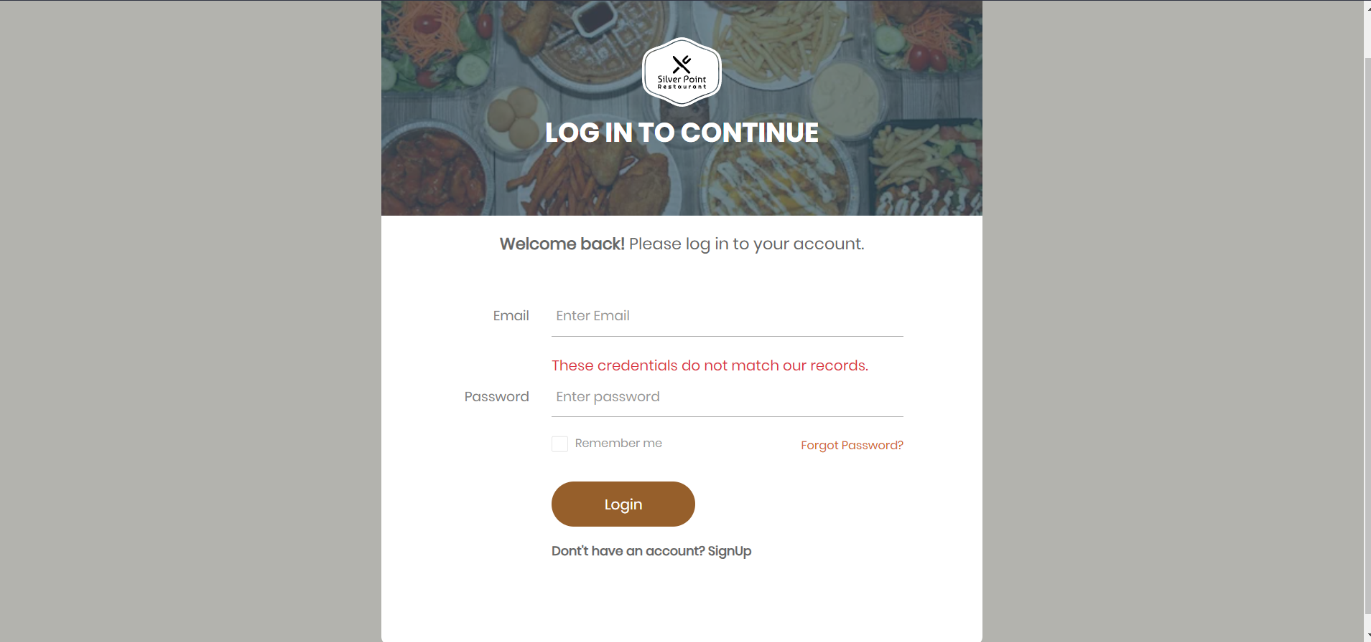

#### Registration Page

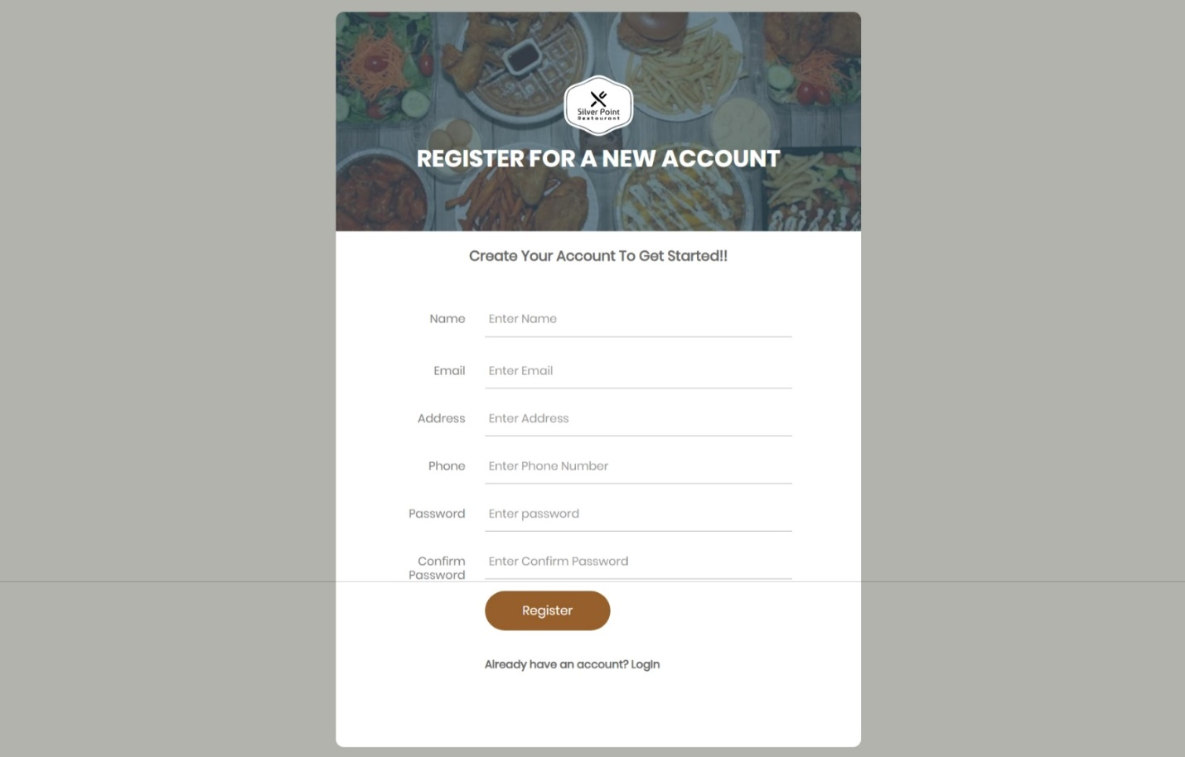

#### Invalid Registration

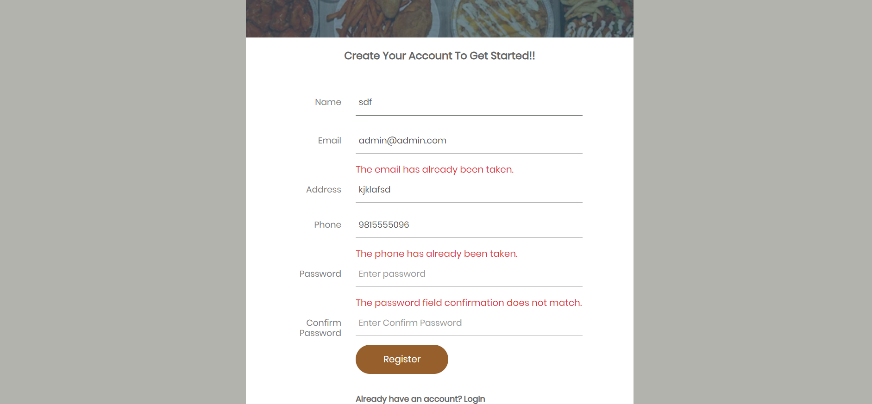

### Cart Page

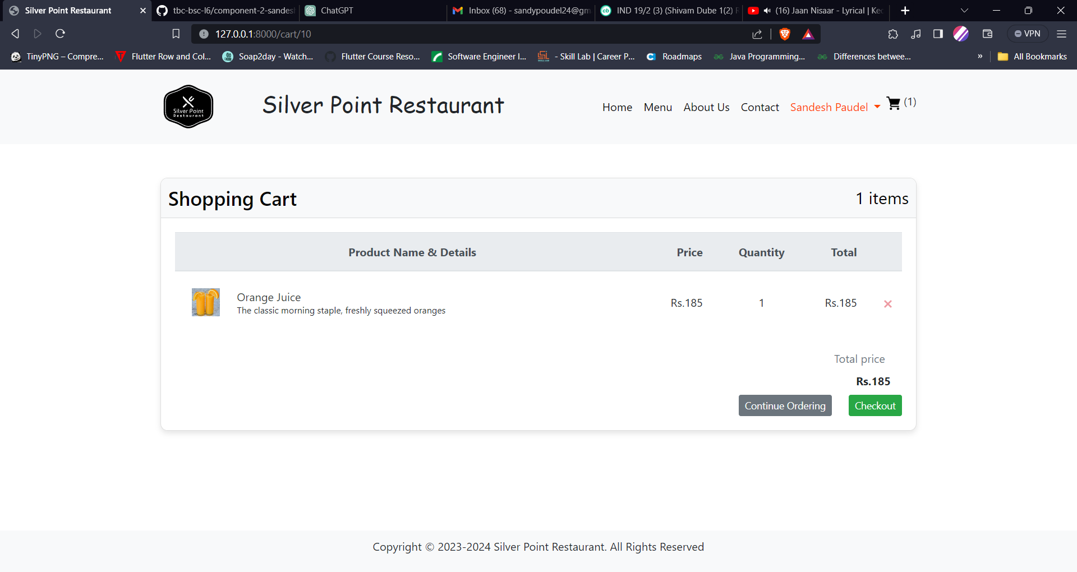

### Checkout Page

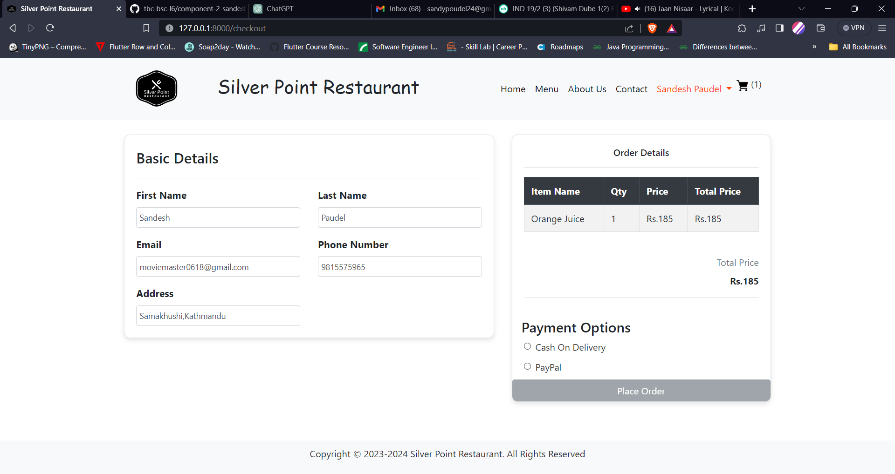

### User Order Page

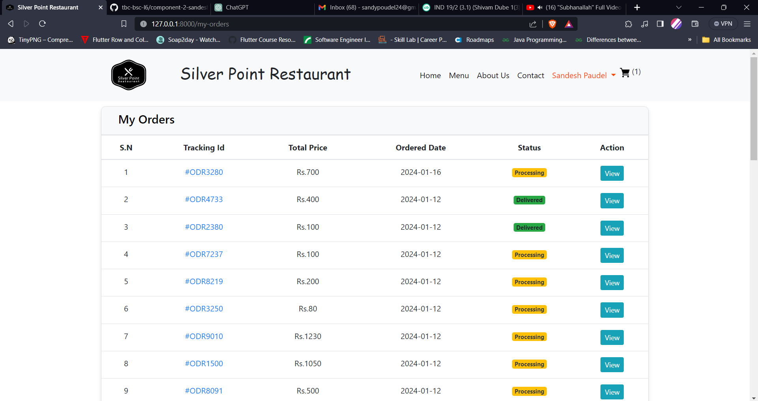

### About Us

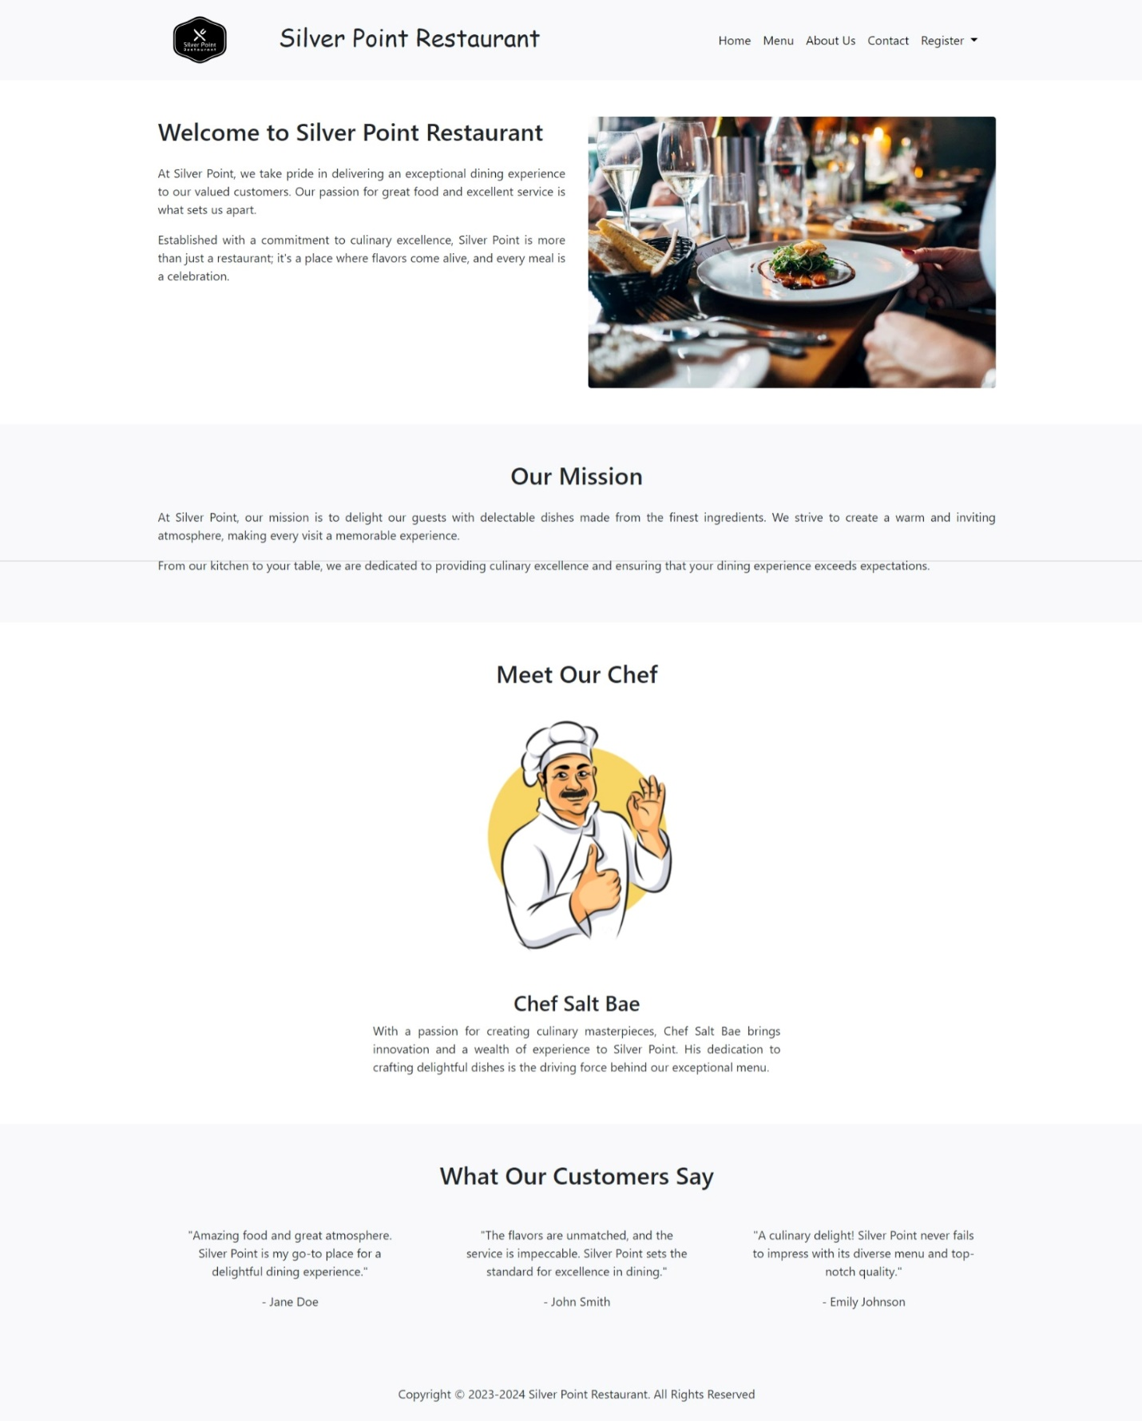

### Contact Us

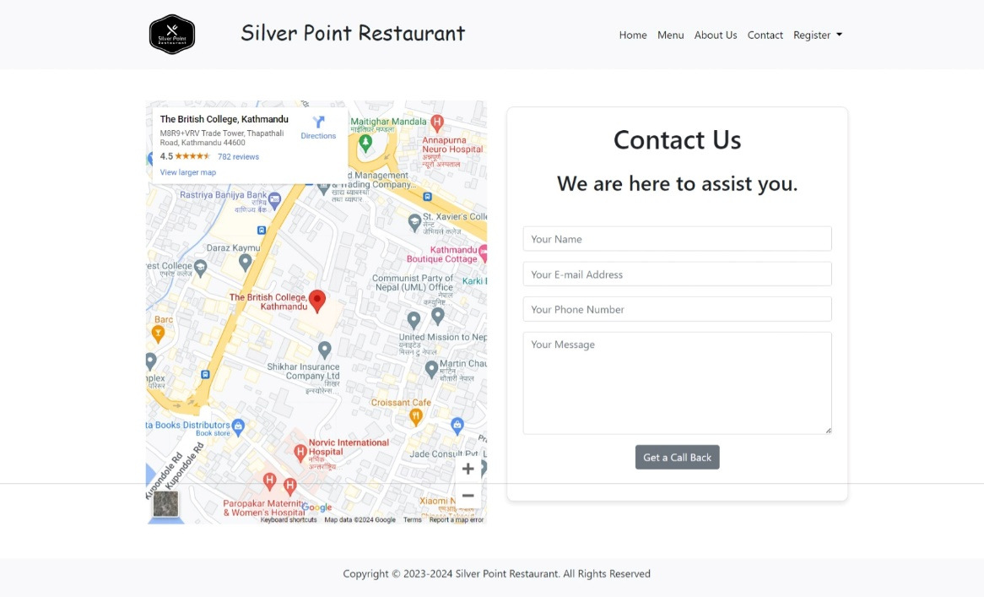

### Admin Dashboard

#### Dashboard Page

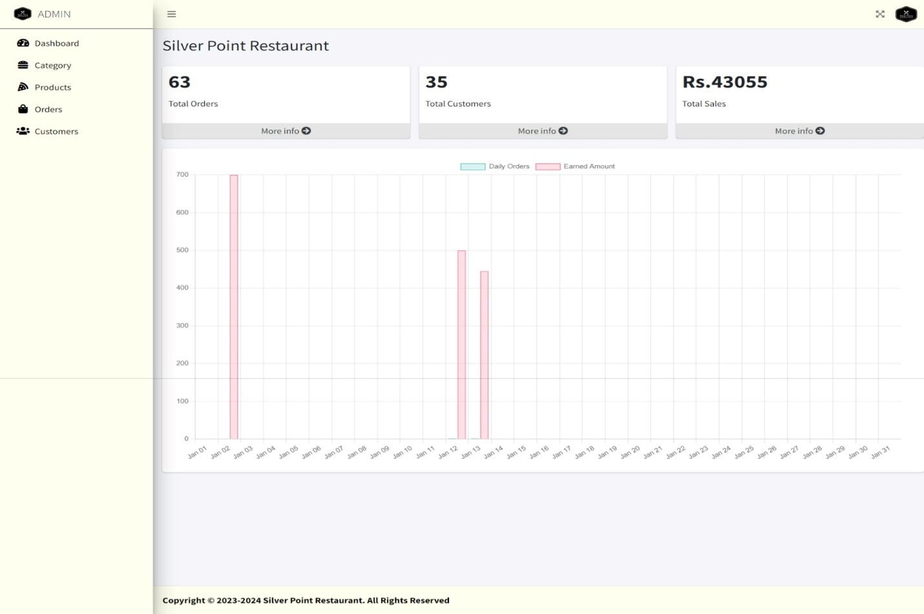

#### Order Page

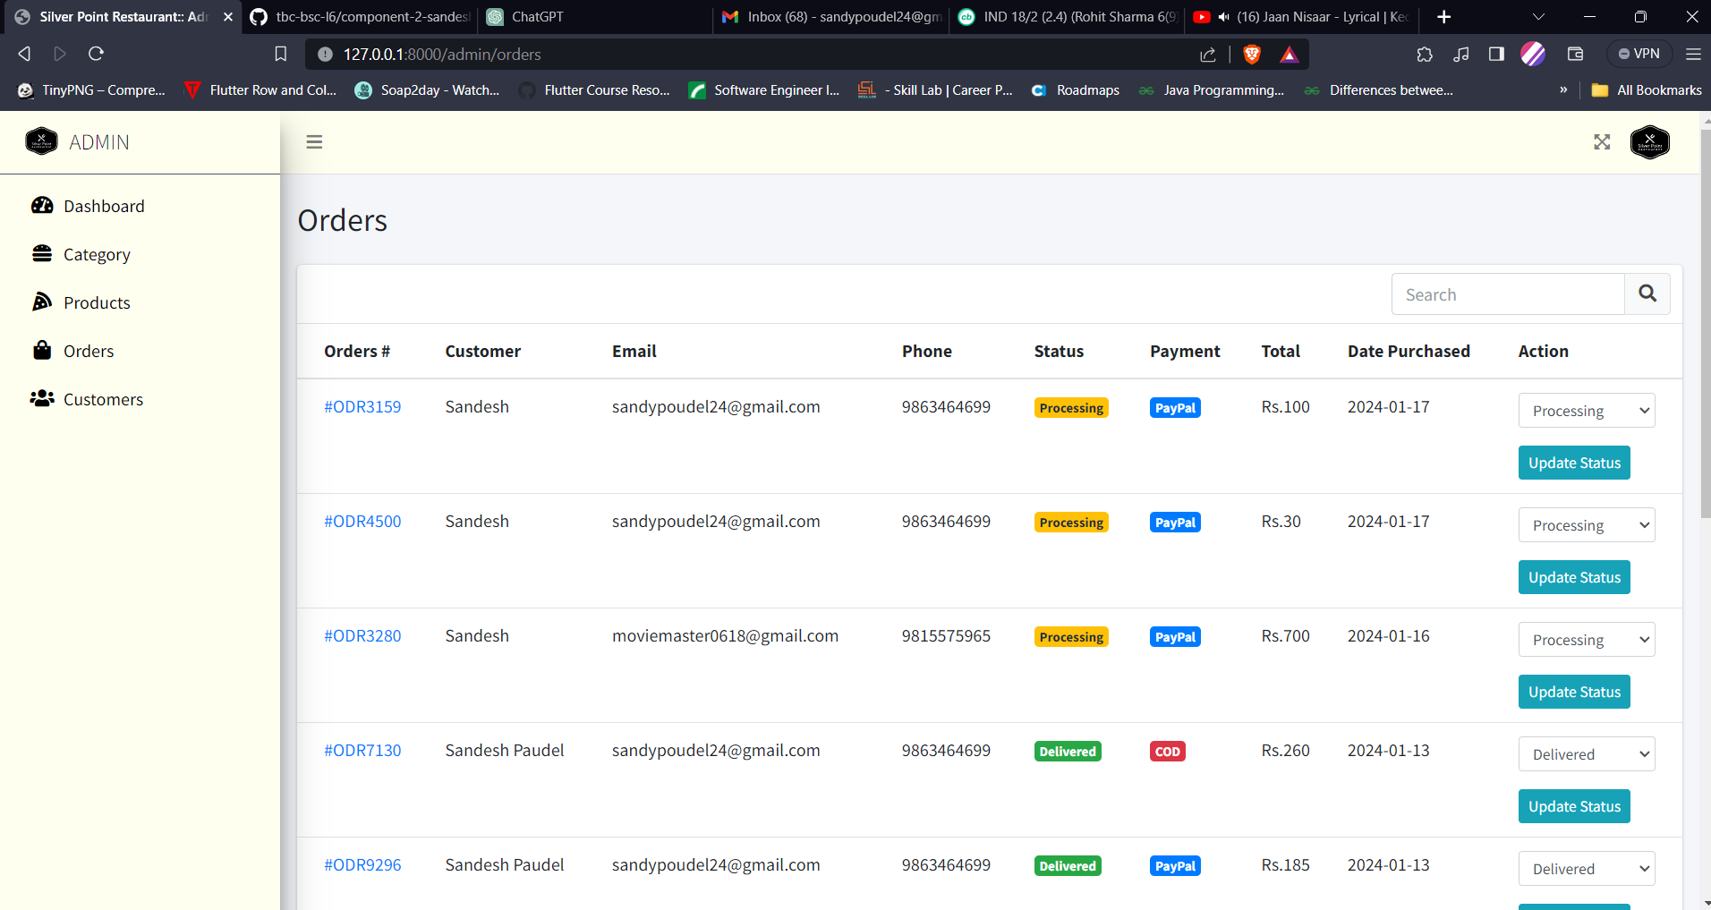

#### User Page

